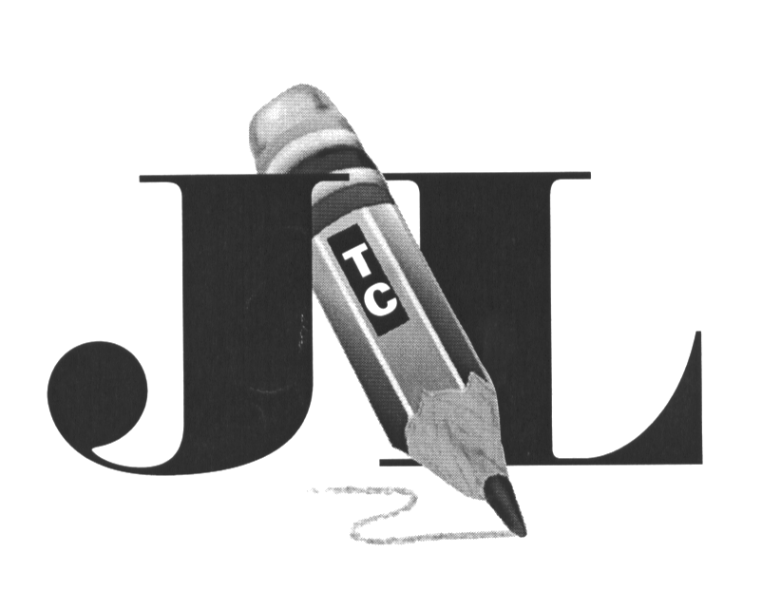
Jefferson-Lewis Teacher Center
Professional Learning Communities Rating Rubric

 | Criteria | 1  Not Addressed | 2  Inconsistent | 3  Satisfactory | 4  Outstanding | Score
1 | Need for Project | Proposal minimally articulates the need for this PLC | Proposal states the need for this PLC in general | Proposal articulates the need for this PLC adequately | Proposal explicitly articulates the need for this PLC and describes it thoroughly
2 | Alignment with Selected Focus Area | Proposal minimally identifies focus area | Proposal broadly identifies focus area | Proposal adequately identifies focus area | Proposal explicitly identifies specific focus area addressed by this PLC
3 | Group Action Plan | Proposal minimally identifies the area of study and what participants will do when group meets | Proposal broadly identifies the area of study and what participants will do when group meets | Proposal adequately identifies the area of study and what participants will do when group meets | Proposal clearly identifies the area of study and what participants will do when group meets
4 | Evaluation of Learning Teacher Practices | Proposal does not demonstrate how teaching practices will be impacted. | Proposal minimally describes how teaching practices will be impacted. | Proposal describes how teaching practices will be impacted, but does not provide specifics. | Proposal clearly articulates how teaching practices will be impacted.
5 | Evaluation of Learning  Student Performance | Proposal does not indicate potential impact on student learning. | Proposal minimally describes potential impact on student learning. | Proposal generally describes potential impact on student learning, but does not provide specifics | Proposal clearly articulates potential impact on student learning.

Total Score____________________/20

Amount Requested______________

Proposal #____________________

Initials of Reviewer_____________

